**Computer Network Lab Exam Exercise Report**

**Objective:**

ToCreate and configure a suitable topology for both LAN and WAN using 10-15

computers, routers, and switches. Simulate the transmission of a message from one network to

a computer in another network.

**Procedure:**

1. **Topology Design:**

○ Design a network topology using Cisco Packet Tracer that includes:

1. **LAN Configuration:** At least 10 computers connected to switches.

2. **WAN Configuration:** Connect the LAN network to another network using

Router.

2. **Network Setup in Cisco Packet Tracer:**

○ **Add Devices:**

1. Place and connect 10-15 computers.

2. Add necessary switches (at least 2 for the LAN setup).

3. Add at least 2 routers for WAN setup.

○ **Configure IP Addresses:**

1. Assign IP addresses to all computers within the LAN.

2. Configure router interfaces with appropriate IP addresses.

3. Set up routing protocols or static routes as needed for WAN

communication.

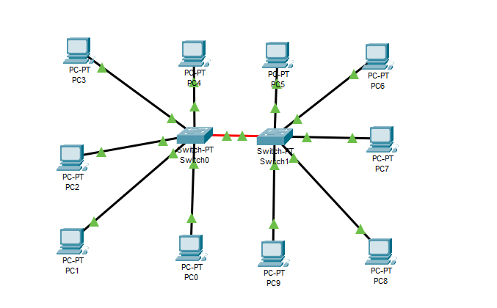

LAN Network

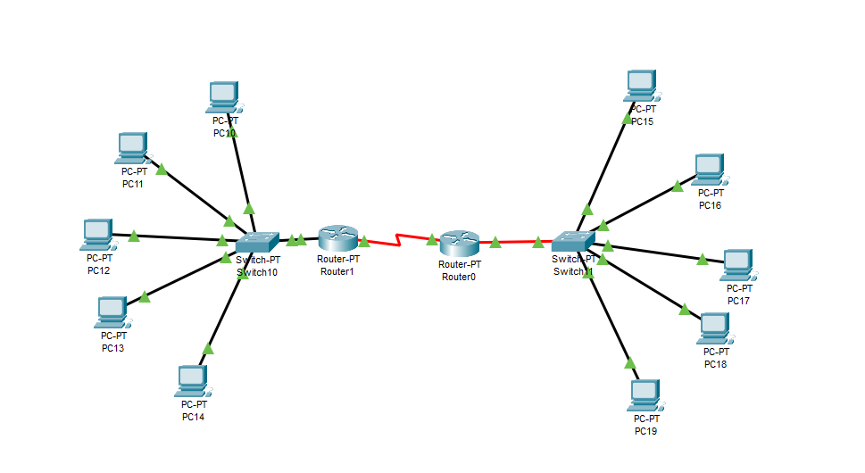

WAN Network

3. **Configuration Steps:**

○ **LAN Configuration:**

1. Connect computers to the switches.

2. Configure IP addresses on each computer.

3. Connect switches with each other as needed.

○ **WAN Configuration:**

1. Connect routers to each other.

2. Configure router interfaces with IP addresses.

3. Set up routing (static or dynamic) to ensure connectivity between the

LANs.

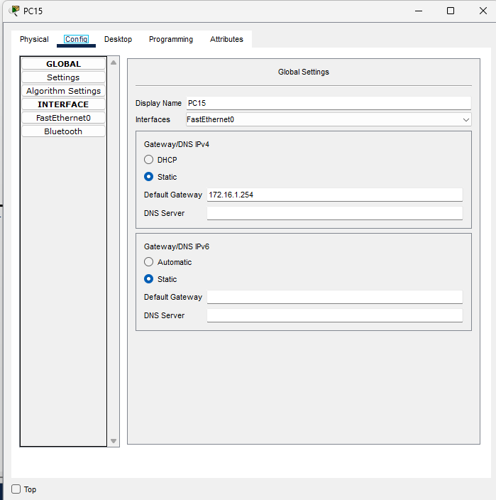

4. **Simulation:**

○ **Send a Message:**

1. Use the simulation mode in Cisco Packet Tracer.

2. Configure and send a message from a computer in one network to a

computer in another network.

3. Capture and verify the message transmission.

**LAN Simulation: Sending PDU from PC3 to PC8:**

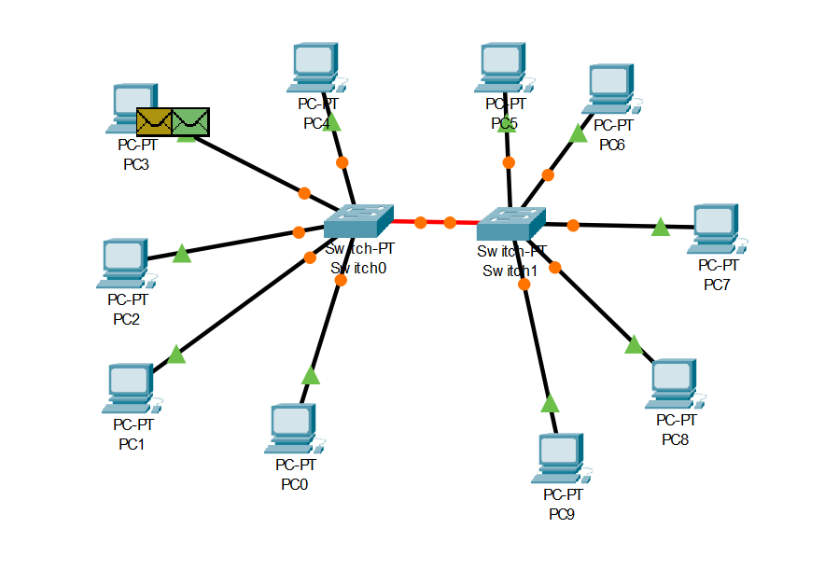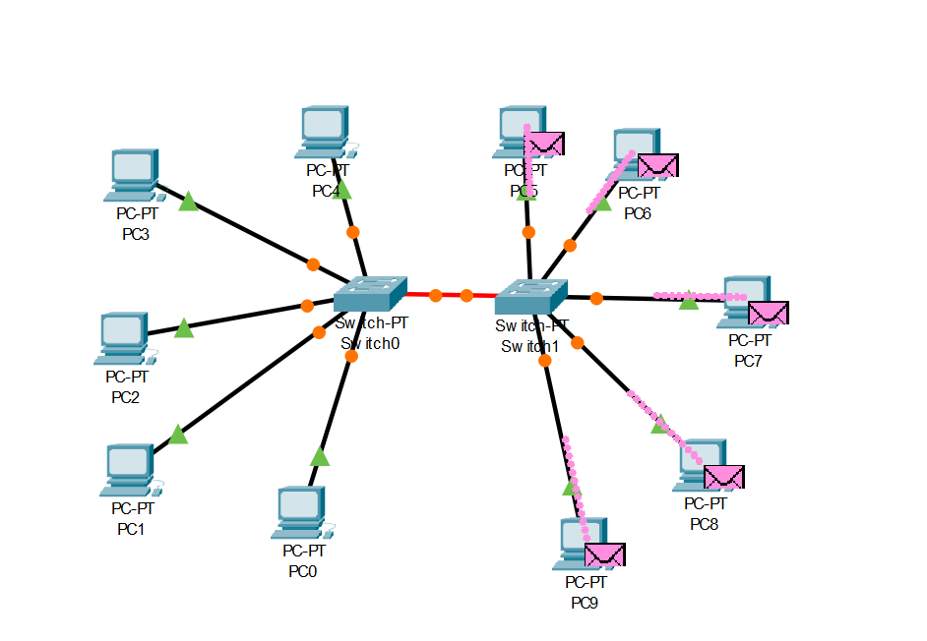

**WAN Simulation: Sending message from PC10 to PC19**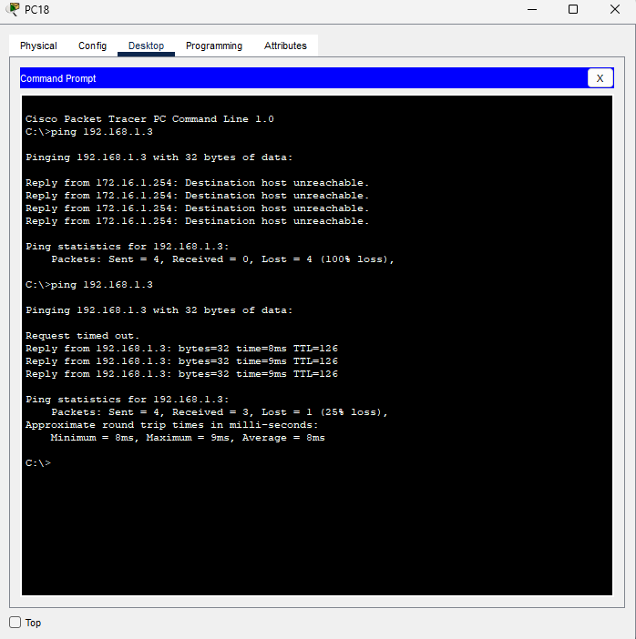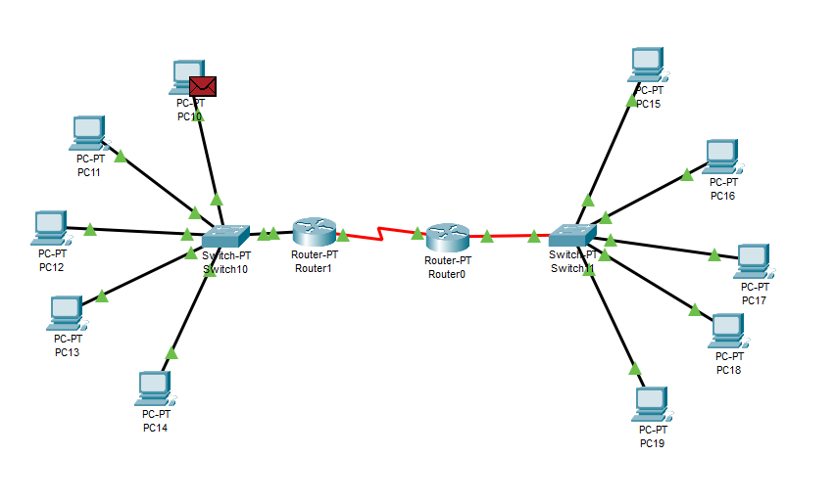 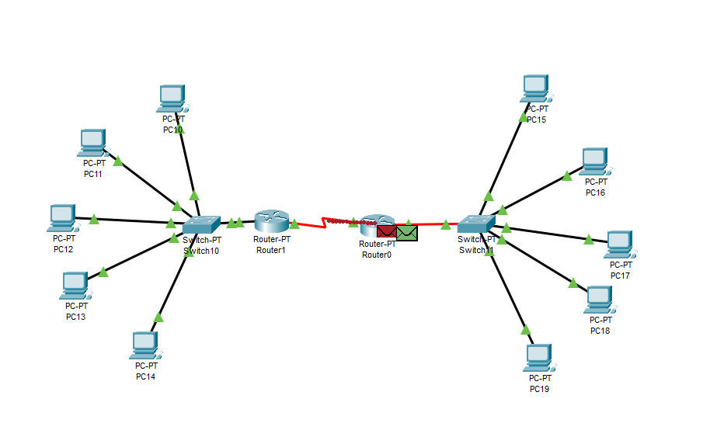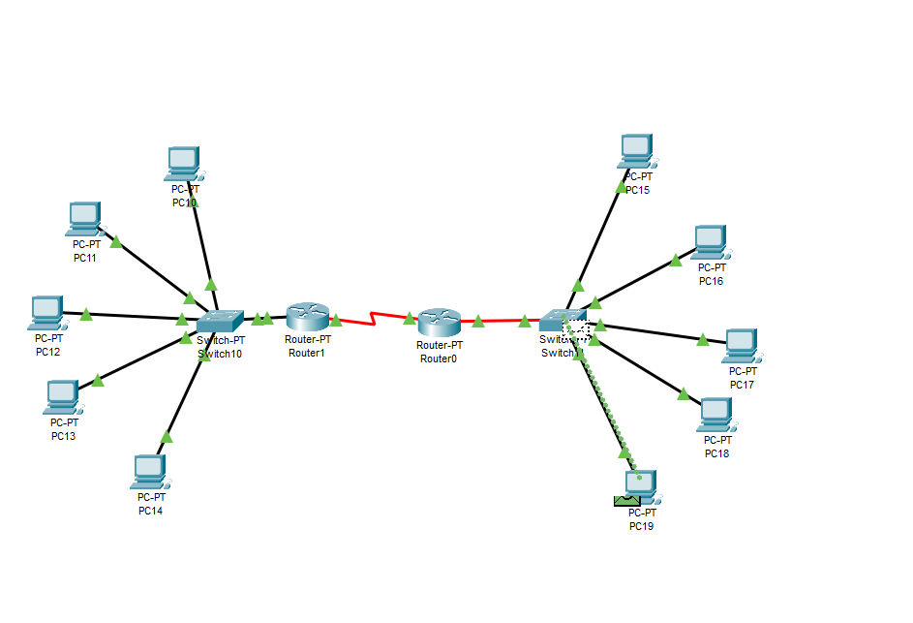

**Results:**

The network topology was successfully designed and configured using Cisco Packet Tracer, incorporating both LAN and WAN setups. The LAN network consisted of 10 computers connected to switches, and the WAN setup involved interconnecting two LANs via routers. Each device was assigned appropriate IP addresses, and routing protocols were configured to ensure seamless communication across the networks. During the simulation, a message was sent from PC3 in the LAN to PC8 within the same LAN, and from PC10 in one network to PC18 in another network through the WAN. The message transmissions were successfully captured and verified, demonstrating the proper configuration and connectivity between the networks.